CP800 User Manual

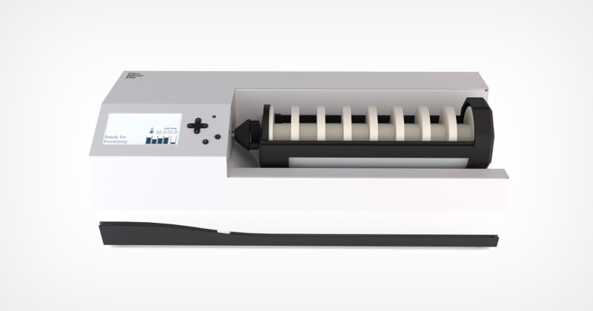

FND

Contact:

Last Updated: 27/04/2022



This work is licensed under the Creative Commons Attribution-ShareAlike 4.0 International License. To view a copy of this license, visit <http://creativecommons.org/licenses/by-sa/4.0/> or send a letter to Creative Commons, PO Box 1866, Mountain View, CA 94042, USA.

Part Lists:

This section lets you check all the parts required to build the machine and it allows the user to learn the naming of each part, so that the readers would understand which parts are being referred to in the instructions of this document hereafter.

# Installation

Pre-setup:

Please check your package for parts/components against the following checklist, please refer to the “Part list” section for the components part code and names with a picture.

Checklist:

Revied parts in pcakge

|  |  |  |  |  |
| --- | --- | --- | --- | --- |
| Part code | Name | Condition | Qty | Check? |
|  | Chassis assembly |  | 1 |  |
|  |  |  |  |  |
|  |  |  |  |  |
|  |  |  |  |  |
|  |  |  |  |  |
|  |  |  |  |  |
|  |  |  |  |  |
|  |  |  |  |  |

The below list is the parts that are not provided in the package and the user is required to source themselves from local hardware shop

Sourcing list;

|  |  |  |  |
| --- | --- | --- | --- |
| Part code | Name | Qty | Check? |
|  | IEC Power cable | 1 |  |
|  | 8mm tubes |  |  |
|  | 10mm tubes |  |  |
|  | 3mm screw driver | 1 |  |

## Adjusting Screen contrast

Once the machines is setup, and all parts and assembly are checked, a

Setting up

**Connecting the plumbing loop:**

The processing tank has to be connected before any plumbing can take place. The connectors between the valves and the processing tank only open when connected. Trying to pump without connecting the tank will result in pressure building up in the connector end, and the plumbing tube will likely to burst out.

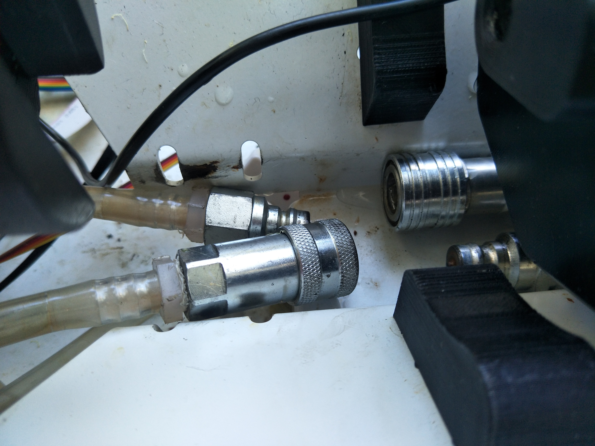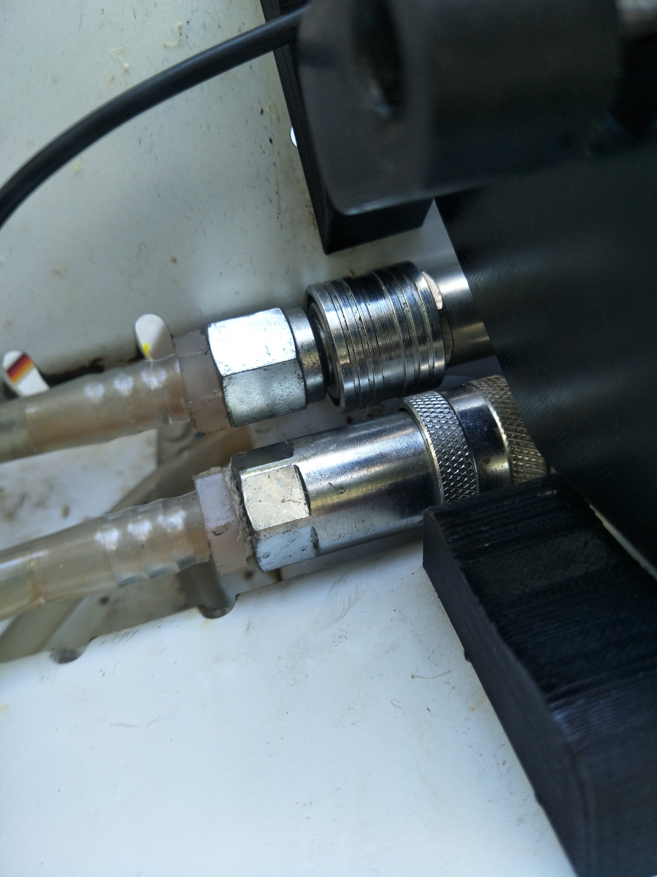

The left picture shows the processing tank is not connected; the right shows the tank is connected.

**Tank leveling:**

The user is required to adjust the level of the fluid inside the processing tank. The fluid level inside the tank should reach the bottom of the rotating shaft along its entire length. Leveling the required to ensure all film along the rotating shaft is developed uniformly.

It is known that the current design of the machine assembly doesn't guarantee rigidity to ensure the tank is installed horizontally, since the tank is simply resting on sleepers and the metal casing underneath has an incline to drain any leaks.

The following procedure is recommended to level the fluid in the tank:

1. Keep the tank open and rest it on the stands
2. Fill the tank with water manually, the unpowered plumbing system should keep the water from draining
3. Place a spirit level meter on the casing of the drum
4. Adjust the spirit level to the center as much as possible by padding the height of either end of the sleeper with the level adjustment blocks (PART no).
5. Double check the water level with dummy rolls to see that the water level covers the bottom section of all rolls along the rotating shaft, repeat from step 2 to 4 until all rolls are submerged properly at rest.
6. Keep the water in the tank, if you wish calibrate the full tank sensor, see section “Calibration of full tank sensor”

It is also important to place the machine on a flat surface, since the rotating shaft is only functional within a small angle from the shaft axis of the DC motor.

**Calibration of full tank sensor:**

Full level sensor is sensing the capacitive of the material against its sensing surface. Capacitive sensing is dependent on the temperature, moisture content, the density of the material and the humanity of the air.

It is recommended to calibrate the sensor at the beginning of each day after the chemicals have been heated up to the desired temperature for the processing. If the ambient temperature has changed significantly during the day or a process operating with chemical at a different than previous processing, it is highly recommended to re-calibrate the full level sensor.

Consider calibrating the sensor in the following situation:

1. When a process operating in different temperature is selected
2. Before the first processing on a new day
3. In the morning, afternoon and night without air-conditioning and operating in a climate where the temperature changes vastly during the day.

NOTE: when tuning the sensor, clockwise turning decreases the sensitivity of the sensor, and counter clockwise increases it.

The following procedure is recommended to calibrate the sensor:

1. Fill and level the fluid level of the tank, see section “Tank leveling”
2. Remove the cap of the sensor and have the nod exposed
3. Connect the sensor and power on the machine.
4. Turn the nod using a flat head screw driver, so the LED is just turned on at the desired water levels.
5. Remove the water content so the tank is empty, and the sensor should be off
6. Place the tank at the horizontal position on the sleeper and keep the machine powered
7. Refill the tank until you see the water level raised high enough to trigger the sensor’s light
8. If the sensor turned on at the desired level, the calibration is now completed, if not, repeat step 5 to 7 until the sensor's light turned on at the desired level.

**Calibration of flow sensors:**

There are two outlet flow sensors. They are to detect water flowing through the tube when the process is emptying the tank. The signal of both sensors is joint electrically to one port on the motherboard, so both sensors have to switch off together to indicate the entire tube is empty thus the tank is empty. This arrangement is made to reduce the chance that a false positive for empty tank when there are air bubbles in the tube. The reason for that is the situation toward the end of the emptying the tank, the water level in the tank will be low enough that the pump will suck air in before the fluid is drained down by gravity on the other side of the tank.

These sensors sense the capacitance within the clip. Thus, consider calibrating the sensor in the same situation as the full tank sensor, which are:

1. When a process operating in different temperature is selected
2. Before the first processing on a new day
3. In the morning, afternoon and night without air-conditioning and operating in a climate where the temperature changes vastly during the day

The following procedure is recommended to calibrate each sensor:

1. Ensure all plugs are secured, the socket on the PCB for flow out sensor is connected to the splitter wires with two inline sockets and one inline plug
2. The splitter wires should act as AND gate for the pull-down signal of the sensor.
3. Check the signal is working properly by holding the sensor bare handed on the metal clip, the LED on the sensor should turned on
4. Navigate to the output check menu: Main menu > (down button X 6) > setting > (down button once) > Output check
5. Pump in fluid to the tank from any input
6. Pump out some fluid and stop while the tube has water content on it
7. Turn the nod on the sensor with a small flat head screw driver to adjust the sensitivity, make sure section with actual water content should trigger the sensor
8. Pump the rest to check if the sensor light turned off too quickly before the tank is low in level
9. Test trial a processing cycle with water to see if the tuning allows a good drainage of the water content inside the tank.
10. Repeat step 5 to 9 if tank not drained, given the tank is physically leveled, else FINISH

**Rotating clutch and rod:**

Just need to make sure the clutch is not loose and it's connected to the motor properly by clamping on to the D-shaft with a bolt/grubscrew, the 3D printing hole of that could be a bit big, so might need to glue or put some paper to increase the friction.

Main Menu:

Navigate the menu using the instruction below:

* + Up button: to move cursor upward
  + Down button: to move the cursor downward
  + B button: return to previous page
  + A button: confirm or to go into the next page based on the option where the cursor is

There are 6 rows to select:

1. Info Screen: display information of processing or not processing
2. Start Processing: display option for starting a process
3. Stop/Clean Process: to stop a current process or conduct a cleaning process
4. Last Processing: to recall and rerun the previous processing (NOT implemented)
5. Edit Processing: to select and edit processing saved in the ROM
6. Setting: to select and inspect the input and output of the machine

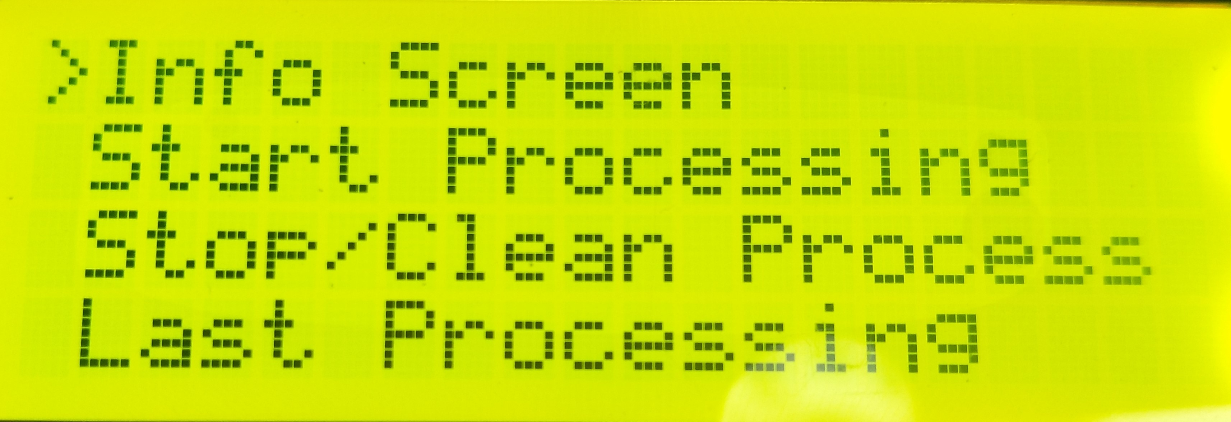

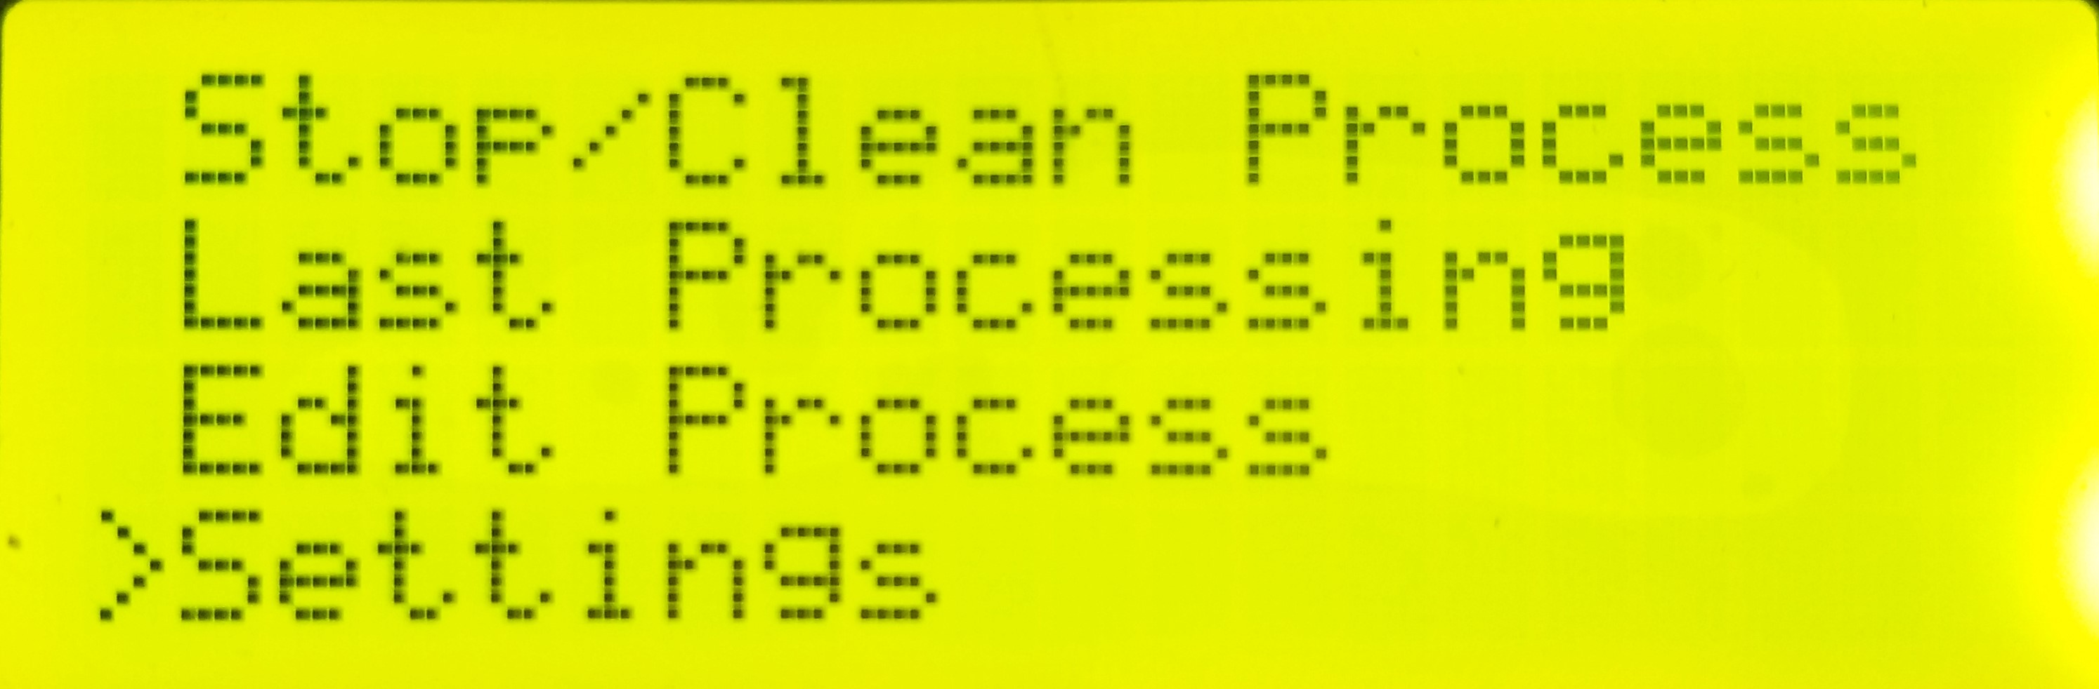

Selecting Processing:

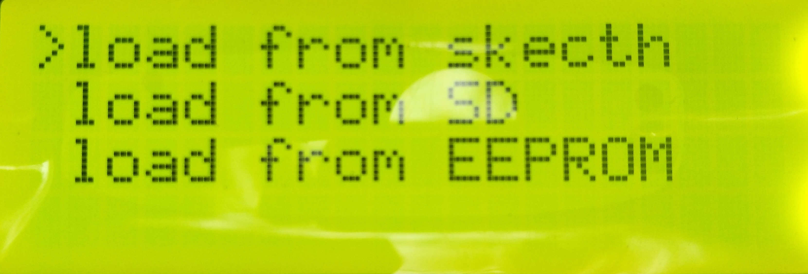

There are two ways to start a film processing:

1. Load from script/sketch (there could be typo), max up to 6 programs
2. Load from SD, due to the limitation of dynamics memory, max up to 12 programs
3. Load from ROM, max up to 6 programs

After selecting the method of loading, there should be a list of programs on display:

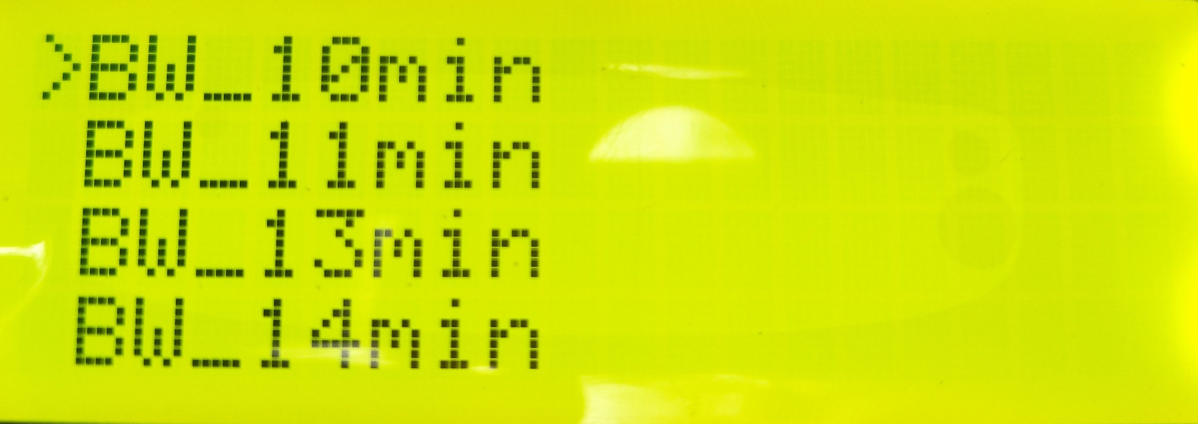

Load from script

There is a default of 6 programs loaded to the script of the machine from FND. This is the easiest way to start processing, since these programs are stored together with the firmware and can be read many times. Program from script can be reuse multiple times without rebooting machine. However, these programs cannot be edited, so the configuration of the machine has to be the FND setup for those processes.

Load from SD

Users can upload their own program via the SD card module. However, Reboot is required to refresh the SD files, or rerun a process from the SD card.

NOTE that the SD card has to be FAT32 format.

Known Issue 1:

The machine froze after selecting “load from SD” in the menu after it has been loaded from SD card once before.

Cause:

The firmware doesn’t allow the SD card module to be reloaded, when there is already an existing module.

Solution:

Reboot the machine before starting a new process from SD card after a previous load

If user is trying to “load from SD”, there are 5 types of error when the operation is unsuccessful.

Error:

1. Card failed, or not present
2. Program file has unmatched number of programs
3. Process step has unmatched size with program header
4. Program file missing
5. Can't open program file from SD card

Possible solution to solve each error

Error 1:

1. Make sure the SD card is insert properly, you should hear a ‘click’ when you pushed the SD card, and the SD card is not bouncing back.
2. Make sure the format of the SD is FAT32

Error 2:

1. Make sure the number of programs within the file matches the actual number of programs stored in the file
2. It is recommended to regenerate the Programs.txt again with the official version of the generator from FND
3. Users could also contact FND with their custom programs to get a properly generated file

Error 3:

1. Make sure the number of steps within the program matches the actual number of steps stored in the program
2. It is recommended to regenerate the Programs.txt again with the official version of the generator from FND
3. Users could also contact FND with their custom programs to get a properly generated file

Error 4:

1. Make sure there is a file named “programs.txt” (none case sensitive) in the SD card

Error 5:

1. Make sure the file named “programs.txt” is not opened by another software
2. Make sure the file named “programs.txt” is not corrupted

Load from ROM

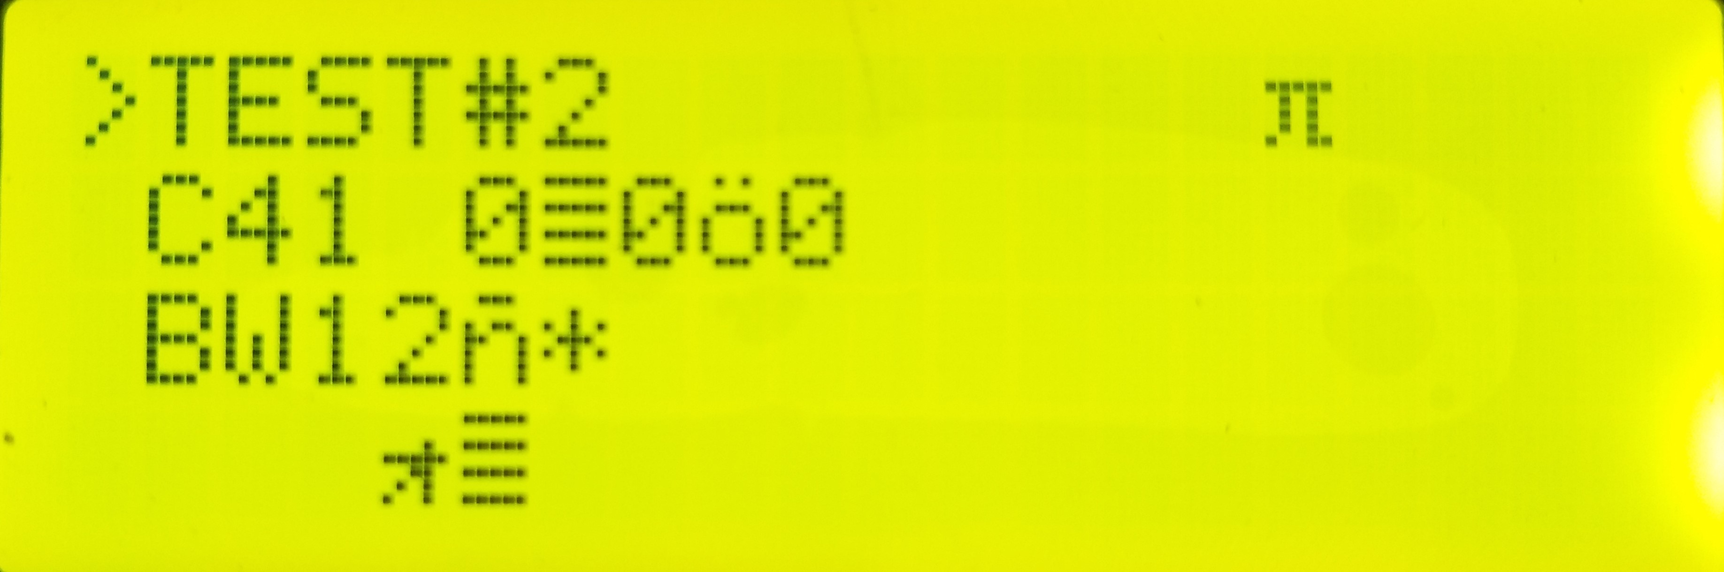

Selected load from ROM will allow users to choose the program they had edited and saved to the EEPROM.

NOTE that the ROM processing is only loaded upon startup of the firmware, and any changes to the ROM programs could only be reflected in the Load from ROM menu after restarting the machine.

There is the possibility that extra characters in the process name are accidentally saved to the ROM from the editing menu. This is caused by the dynamical memory used in the editing menu, and extra char might be present when saving the data array with undefined characters. This WILL NOT cause any operation issue to the processing itself.

Processing:

* Confirmation page:
  + Up button: +1 for pushing (increase dev time for 20%)
  + Down button: -1 for pushing (increase dev time for 20%)
  + B button: return to previous menu
  + A button: confirm and start
  + Others: does nothing

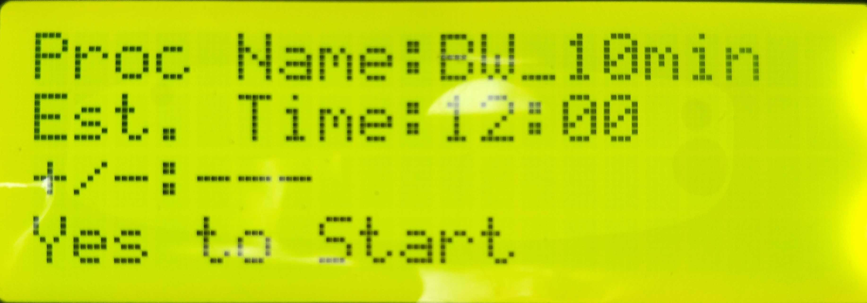

* Infopage during processing
  + Up button: flow in overwrite toggle (see
  + Down button: skip add to remove / skip remove to next step
  + B button: return to previous menu
  + Others: does nothing

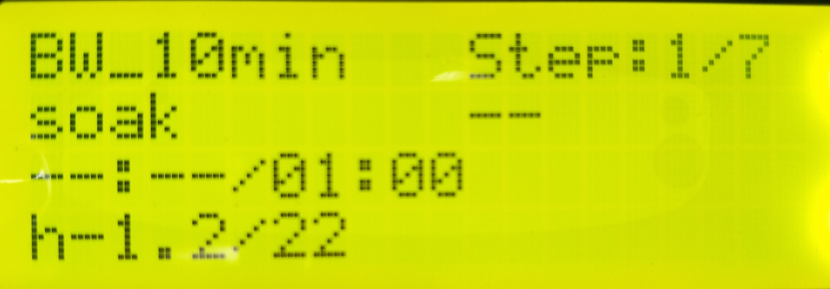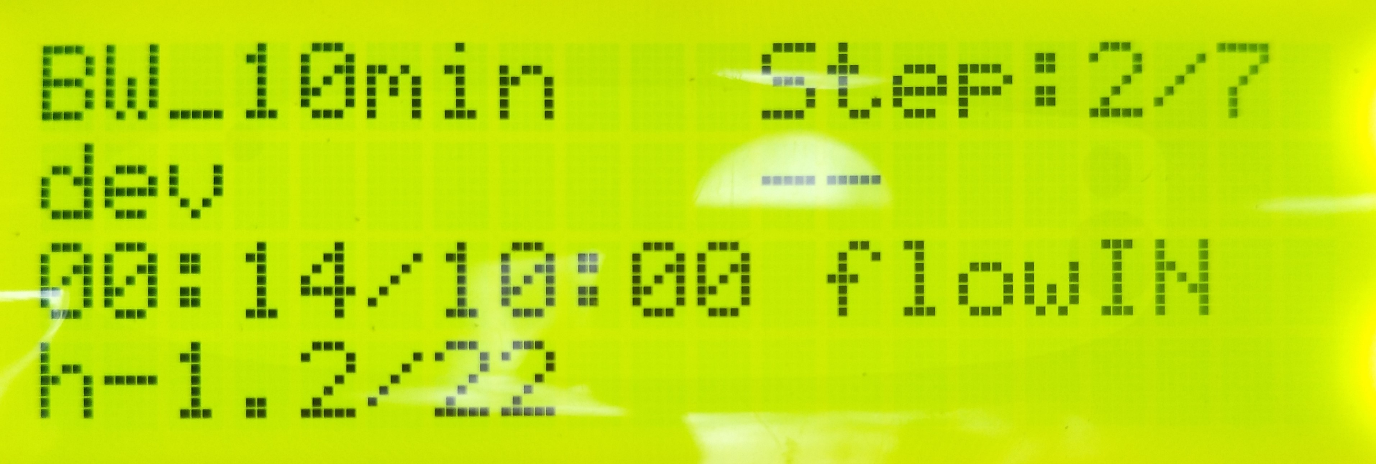

* Stop process
  + Navigate to Stop processing from the main menu
  + Select Stop Processing

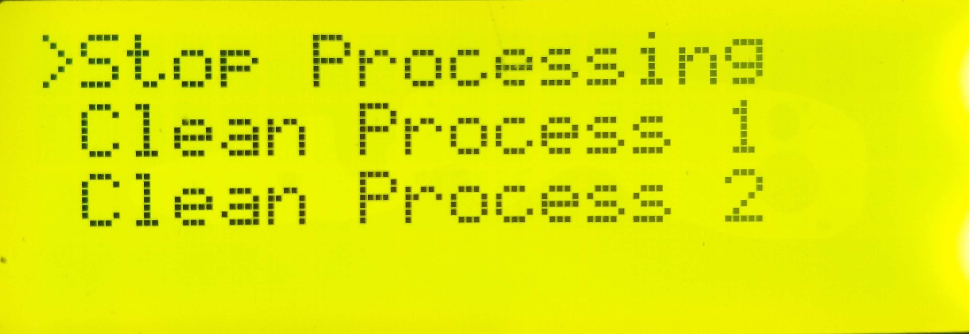

* + Press A to confirm Stopping

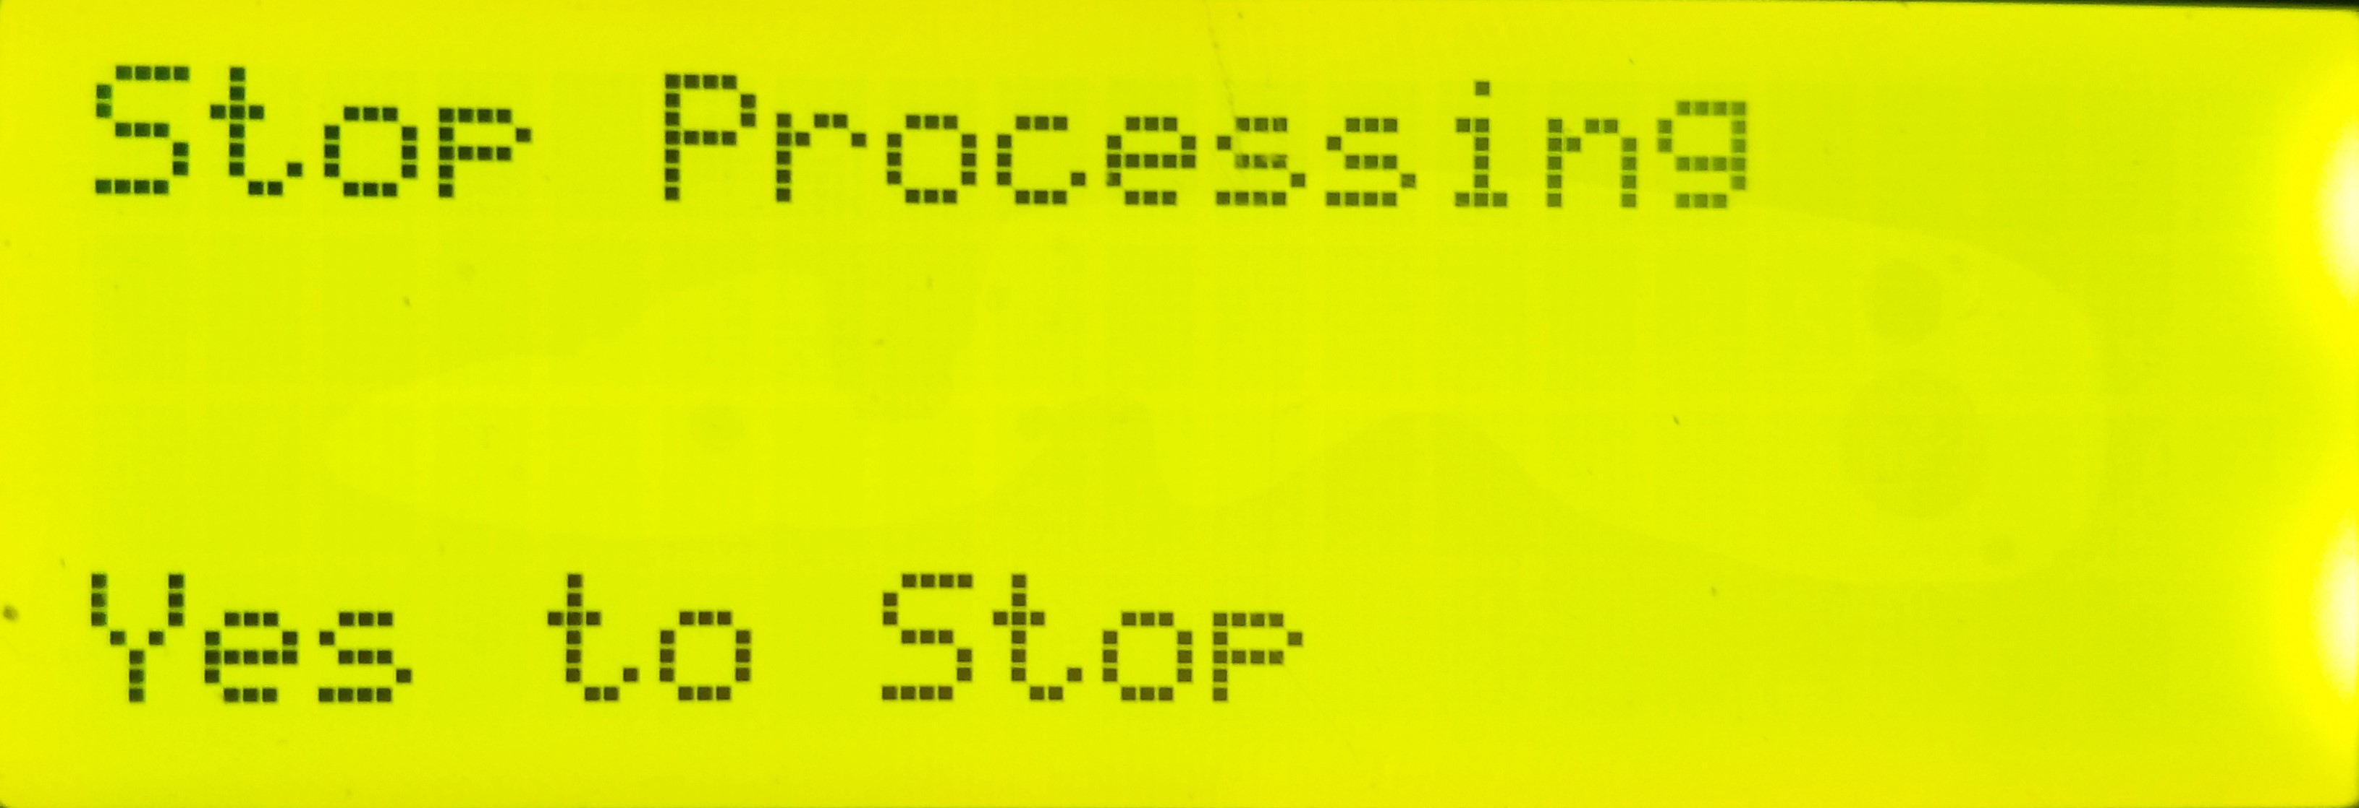

Editing ROM Processing:

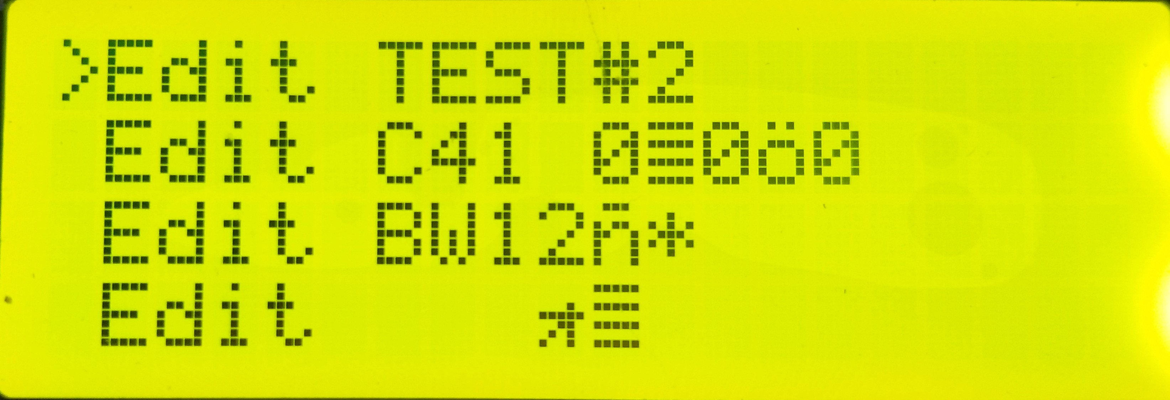

Entering the selection menu of edit processing would show the list of ROM programs that the user could edit, max of programs is 6.

NOTE that the editing is done in a buffer on the menu, and the changes reflected on the menu does not mean it is saved to the EEPROM.

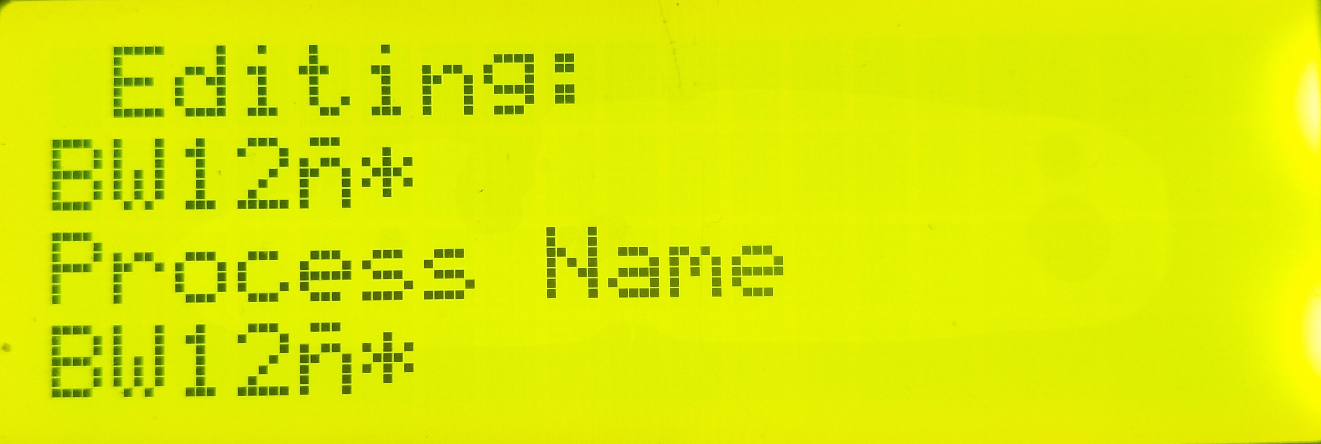

After selecting a program to edit you can browse the parameters of the processing using the general control. Saving is done automatically when you make a change in any parameter and return back to the editing selection menu.

General control:

* + Left button: go to the previous parameters
  + Right button: go to the next parameters
  + B button: return to previous menu and save to ROM if changes had been made
  + A button: enter editing mode for the current parameters

If editing mode is active, the top left corner of the screen will have a flashing black block

Editing mode control:

* + Up button: increase the value of parameter by 1
  + Down button: decrease the value of parameter by 1
  + Left button: select the previous character (for process Name only), or decrease the value of parameter by 10 (for all other parameters)
  + Right button: select the next character (for process Name only), or increase the value of parameter by 10 (for all other parameters)
  + B button: exit editing mode without changes
  + A button: exit editing mode with changes made on the editing menu

***\*note if you select 5 steps then you need make sure you edit all 5 steps before you can save it properly on the rom.***

Saving ROM Processing:

Saving is done automatically when you make a change in the parameters and return back to the editing selection menu.

Cleaning up

It is recommended to perform a cleanup at the end of the day, and after a long time without running it. The cleanup procedure is using clear water and relying on the pump to rinse inside machine. All outlet water should be discarded as waste.

1. Go to “output check” menu: Main > Setting > Output Check
2. Press right to reach the first input tanks
3. Prepare a container fille with water
4. Put one end of both tubes into the container filled with water if you intend to reuse the water, if not, one the output tube in another container which will be discarded as waste later
5. Prepare two pumping tubes and connect one on the first input valve and the other on the first output valve
6. Using the menu to turn on the input and start filling the processing tanks
7. Once water is checked to be pumping in properly at the desired flow rate, skip to the first remove chem on the menu
8. Turn on the output using the menu and let all the water drain
9. Detach both tubes on the valves and attach them to the next valve input/output
10. Repeat step 5 to step 9 for all the other valve until no more valve is untested, and refill the iput container if needed
11. To clear the inside of the valve from water as much as possible, go back to addChem1 from the menu
12. Turn on the input valve in order and let it pump in air for around 5-10s each valve, WD40 can be sprayed into the valve to repent the water out of it
13. Repeat step 12 for all the output
14. Finish

If any valve has a significant difference in flow rate, and the water has become dirty from flowing through it. It could indicate there is a blockage or corrosion inside the valve. It is recommended to take the valve apart and clean it thoroughly.

Maintenance

**Flows Sensors**

The full and empty flow sensor should be tested regularly. Full level sensor on the drum should be calibrated so the LED on the sensor is turned on at the desired level by the user. Similarly, the outlet flow sensors should be tested during a manual pump cycle so that the operation would guarantee proper pumping for each process. Due to the moisture and chemicals of film processing, the contact of the sensor may be affected over time. Please do keep the contact clean when the machine is not being used and apply WD40 regularly to keep moisture out of the contact.

**Plumbing**

The machine should be pumping the hose and the valves dry before the machine is switched off overnight. Emptying the inlet can be done by manually actuator each valve into the drum, as for the full tanks. It shouldn't be too much fluid inside the pumping. It could also be empty by manually actuator each valve from the drum, what emptying each valve and the pump, WD40 should be applied to keep moisture from building up inside the solenoid valves.